Steps taken:

1. Created VPC network:

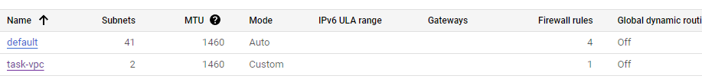

1. Adjusted 2 subnets:

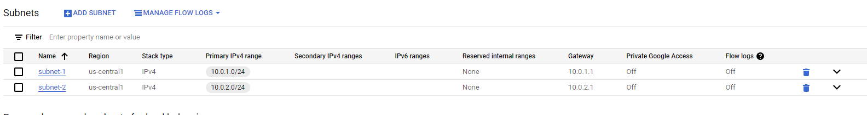

1. Configured VMs, so vm-1 was on subnet-1, vm-2 on subnet-2:

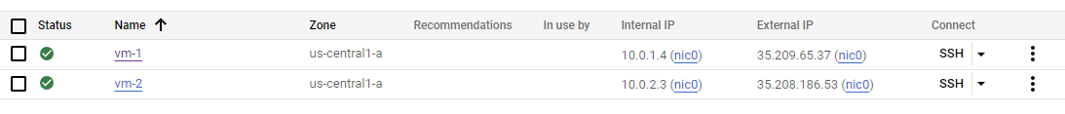

1. While connecting to VM through SSH encountered error:

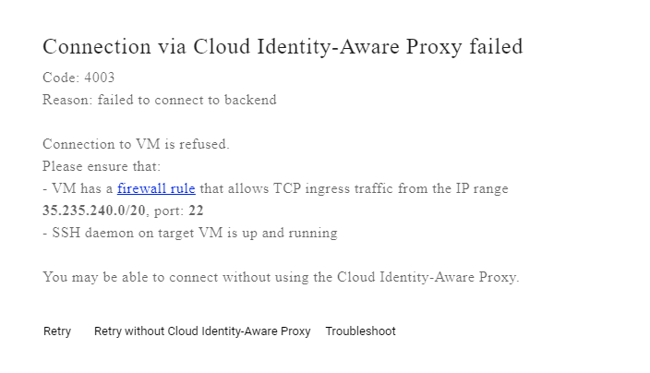

1. To fix adjusted firewall rule:

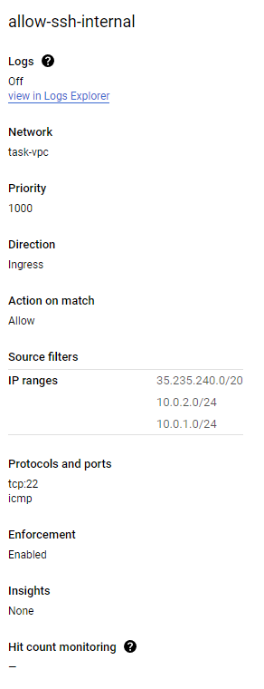

1. After problem fixed, pinged from vm-1 to vm-2:

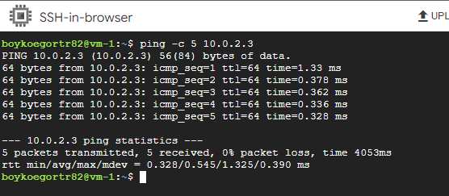

1. Pinged from vm-2 to vm-1:

